**BTech ECE - Quantum University - Batch 01 - Task 05 - Case Study IBM Agile Model In DesignThinking.**

# Case Study: IBM's Integration of Design Thinking and Agile:

IBM, a multinational technology corporation, recognized the need to enhance its product development process to better meet customer needs and stay competitive.

To achieve this, IBM integrated Design Thinking with Agile methodologies, fostering a user-centered and iterative approach to innovation.

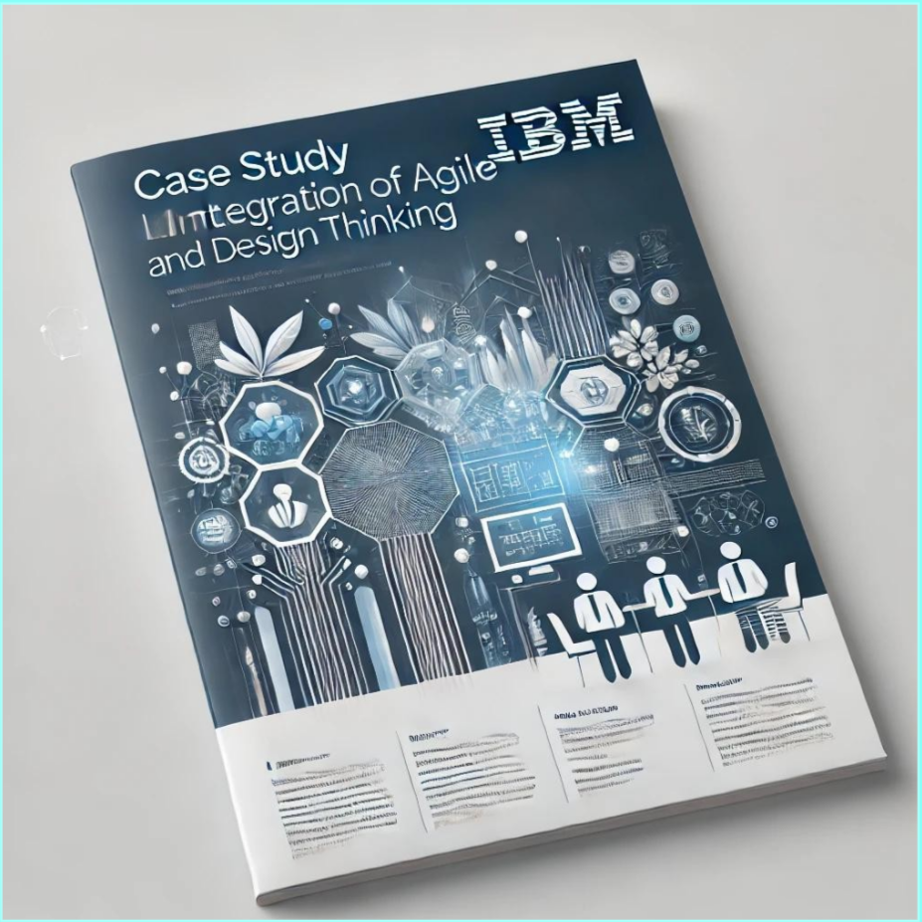

# Methodologies Used:

## Design Thinking

IBM adopted Design Thinking to deeply understand user needs, redefine problems, and create innovative solutions. This approach emphasized empathy, ideation, and prototyping, ensuring that products aligned with real-world user requirements.

## Agile Development

Complementing Design Thinking, IBM implemented Agile practices to develop products in iterative cycles, allowing for flexibility and continuous improvement based on user feedback. Agile facilitated rapid prototyping and testing, ensuring effective solution evolution.

# Challenges Faced:

* + Cultural Shift: Moving from a traditional, process-driven approach to a flexible, user-centered mindset.
  + Skill Development: Employees needed training in Design Thinking and Agile to implement the methodologies effectively.
  + Coordination: Aligning cross-functional teams to collaborate under the combined framework posed initial challenges.

# Outcomes Achieved:

* + Enhanced Innovation: More innovative solutions aligned with user needs, resulting in higher customer satisfaction.
  + Improved Collaboration: Cross-functional teams worked cohesively, leveraging diverse perspectives to solve problems.
  + Faster Time-to-Market: The iterative nature of Agile and user-focused insights from Design Thinking accelerated product development.

# Conclusion:

IBM's successful integration of Design Thinking and Agile methodologies demonstrates the potential of combining these approaches to drive innovation and improve product development processes. By focusing on user needs and embracing iterative development, companies can enhance their responsive⁸ness to market changes and deliver more effective solutions.

# References (Click to Open):

* [Roach, T. (n.d.). How to combine Design Thinking and Agile in practice. Medium.](https://medium.com/startup-frontier/how-to-combine-design-thinking-and-agile-in-practice-36c9fc75c6e6)
* [Dobrigkeit, F., Matthies, C., Teusner, R., & Perscheid, M. (2021). Joining Forces: Applying Design Thinkin](https://arxiv.org/abs/2109.06578)